**1.ReactJS-HOL**

* Installation

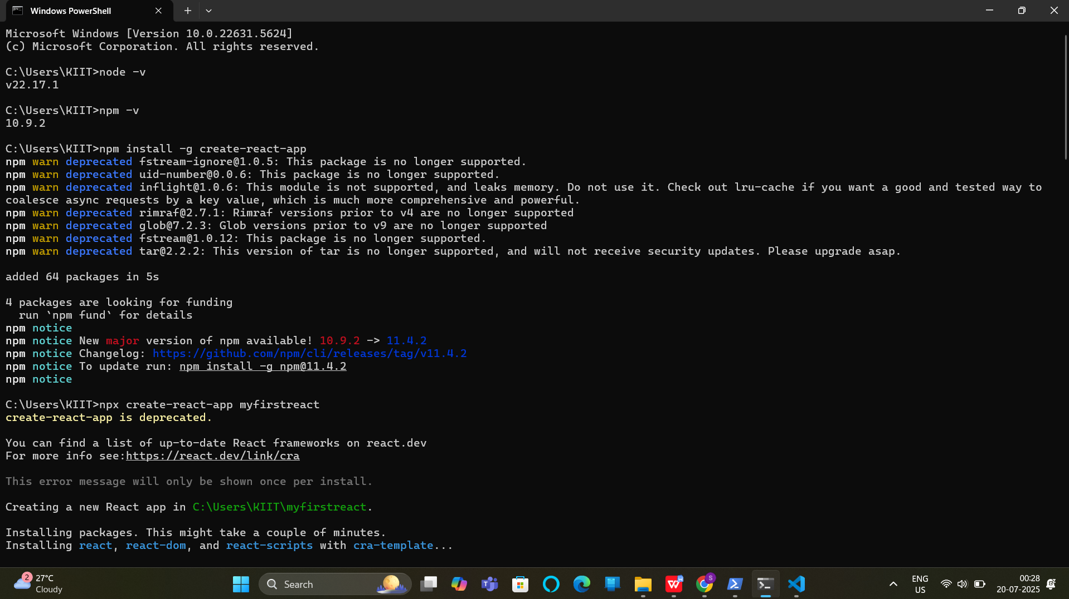

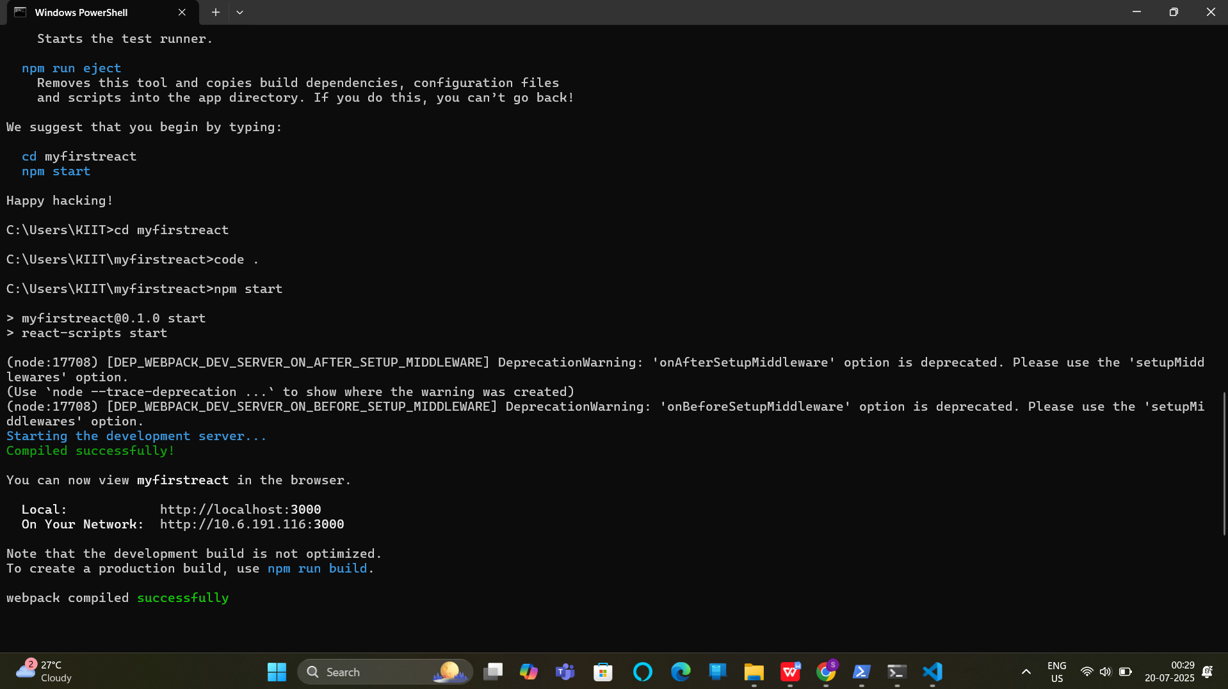

**Code:**

import React from 'react';

function App() {

return (

<div>

<h1>Welcome to the first session of React</h1>

</div>

);

}

export default App;

**OUTPUT:**

